This is the landing page where it allows staff to log in to the staff portal and patients to access the external user portal. It also provides information about the family clinic and its services
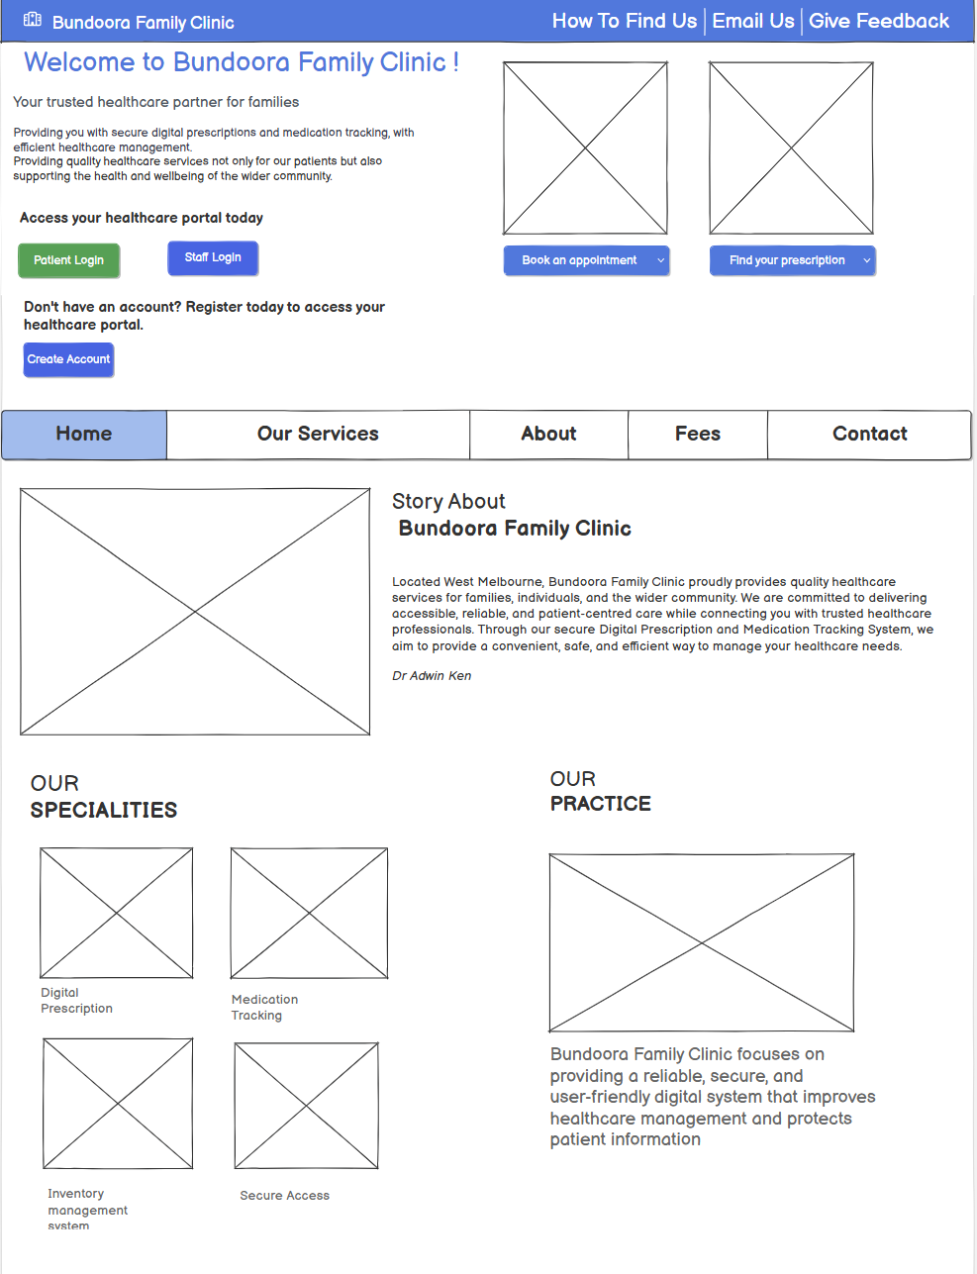
Landing page continued…
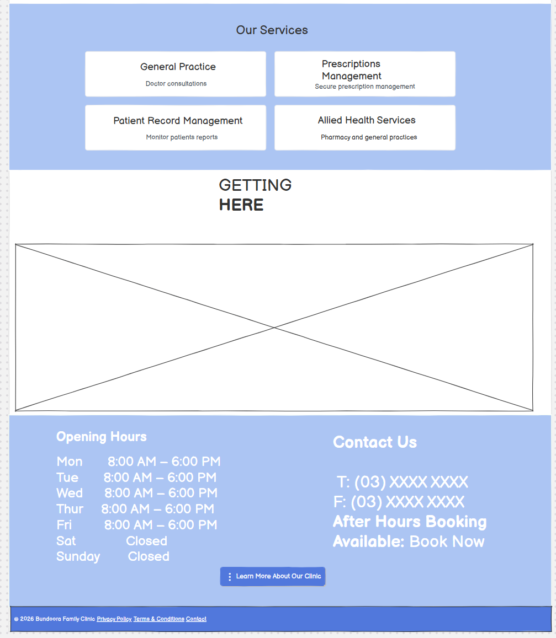

This is the login portal where all users enter their credentials before accessing their specific role-based portal.
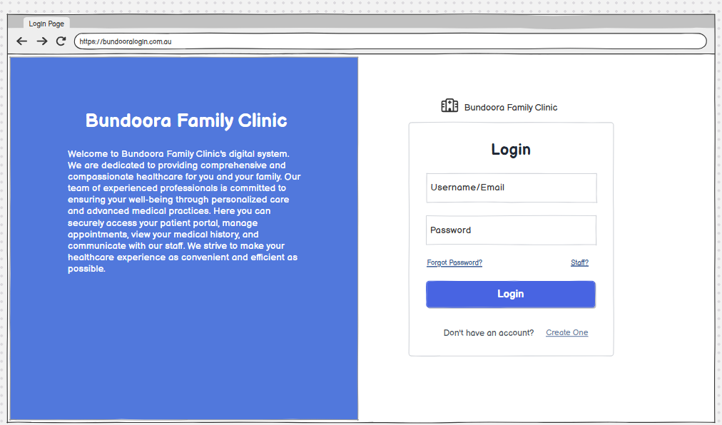
If the user clicks the Staff link, they will be directed to the staff login portal.
They can choose roles accordingly for there.
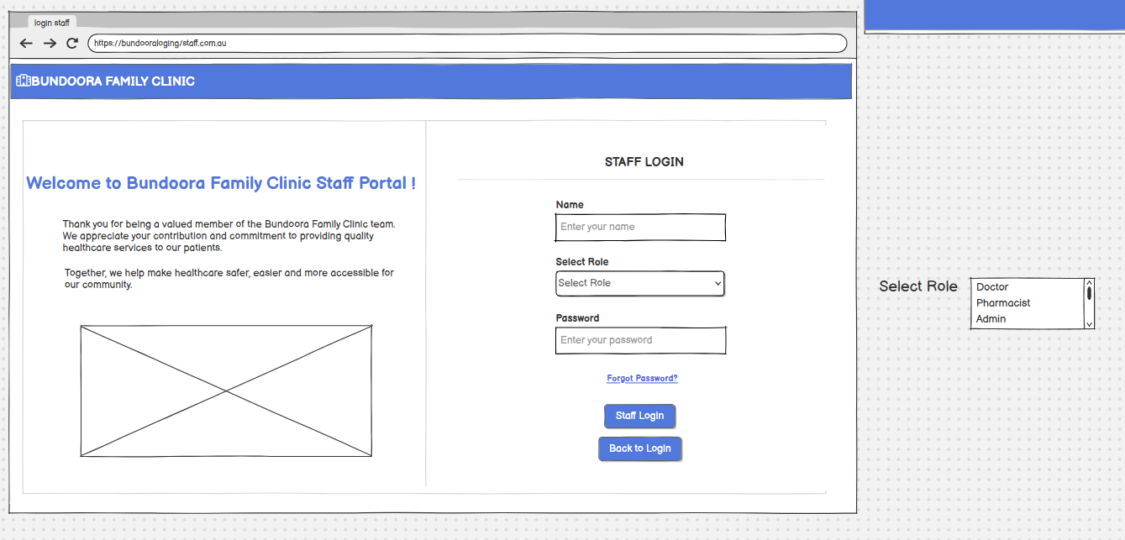
If the password is incorrect, an error message will be displayed.

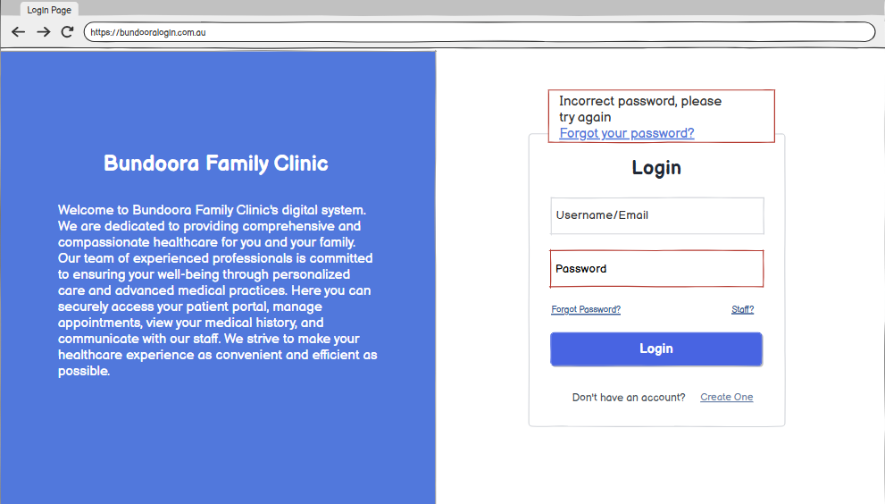
When the user forgets their password, they can select Forgot Password to be directed to email verification, which authenticates their identity.
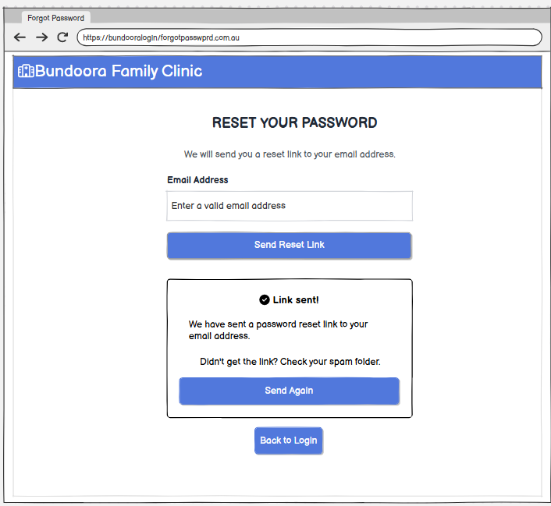

Then, an OTP code will be sent to their email address for verification. The user must enter the six-digit code to change their password.
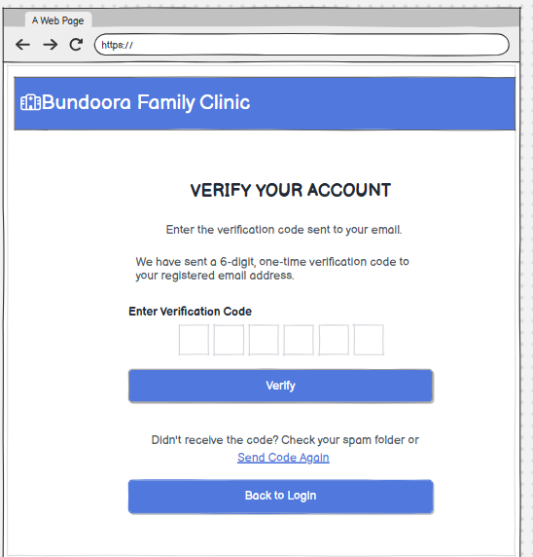

New users can click Sign Up and complete the registration form. All fields marked with an asterisk (*) are required.
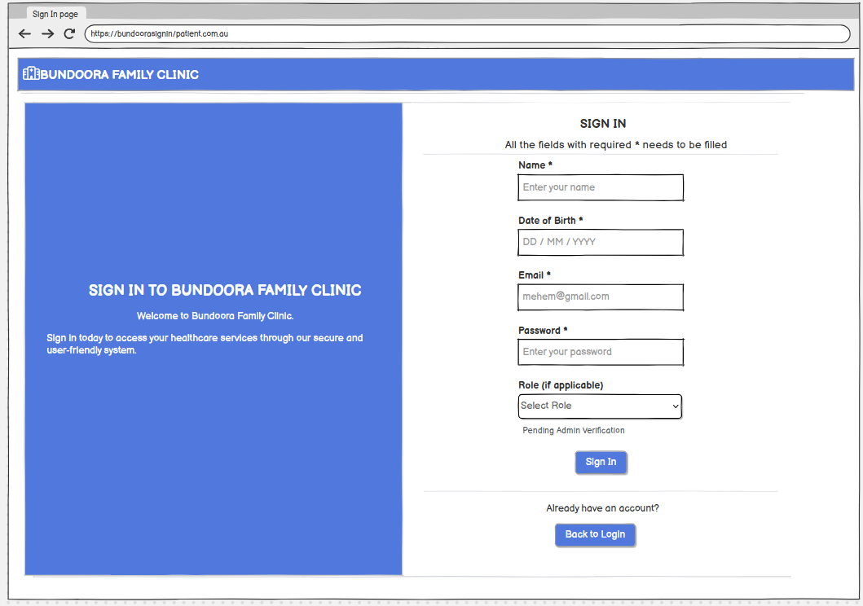
When a doctor logs in, they are directed to the Doctor Dashboard.
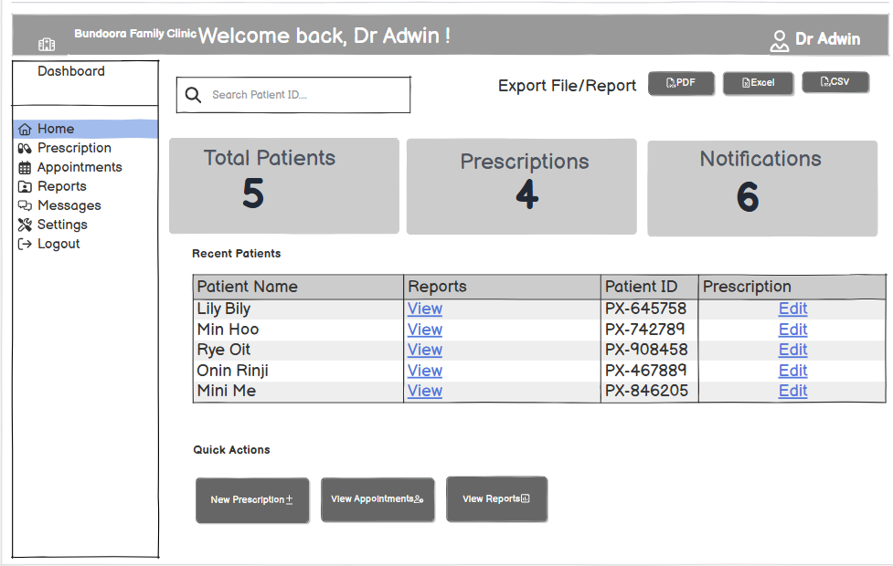
When the doctor clicks View Report from the Quick Actions section or selects View Report next to a patient, they can access and review the selected patient’s medical report.
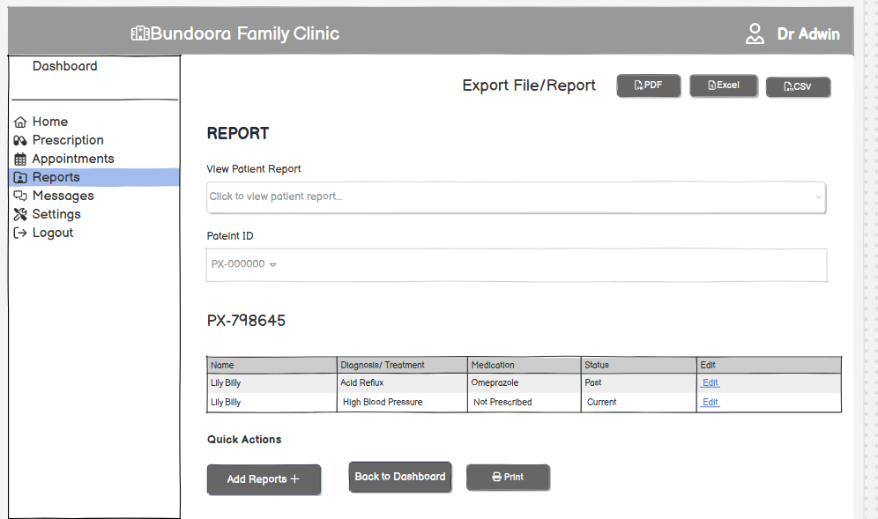
When the doctor selects New Prescription from Quick Actions or chooses Prescription beside a patient’s name, they can search for the patient using their unique Patient ID. The doctor can then create a new prescription, view existing prescriptions, and edit or update prescription details when required.
